**Task 2**

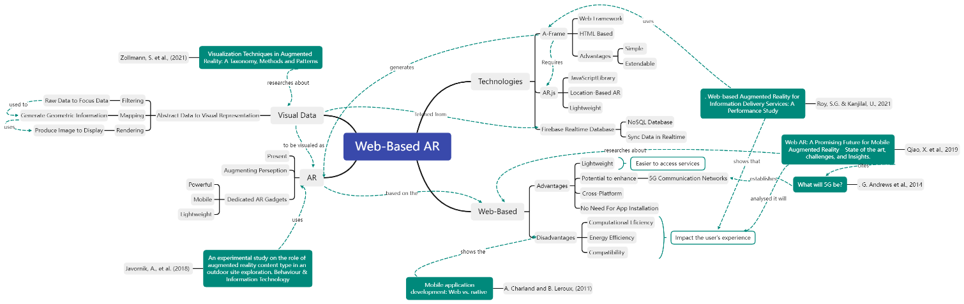

*Concept map is also attached*

Qiao, X. et al., 2019. Web AR: A Promising Future for Mobile Augmented Reality—State of the art, challenges, and Insights. Proceedings of the IEEE, 107(4), pp.651–666.

Roy, S.G. & Kanjilal, U., 2021. Web-based Augmented Reality for Information Delivery Services: A Performance Study. DESIDOC Journal of Library & Information Technology, 41(03), pp.167–174.

Ahn, S., Ko, H. & Yoo, B., 2014. Webizing mobile augmented reality content. *New Review* of Hypermedia and Multimedia, 20(1), pp.79–100.

Javornik, A., Kostopoulou, E., Rogers, Y., Fatah gen Schieck, A., Koutsolampros, P., Maria Moutinho, A. and Julier, S., 2018. An experimental study on the role of augmented reality content type in an outdoor site exploration. Behaviour & Information Technology, 38(1), pp.9-27.

Zollmann, S., Langlotz, T., Grasset, R., Lo, W., Mori, S. and Regenbrecht, H., 2021. Visualization Techniques in Augmented Reality: A Taxonomy, Methods and Patterns. *IEEE Transactions on Visualization and Computer Graphics*, 27(9), pp.3808-3825.

Although the concept map allows to have a visual representation of my study, it can be visually overwhelming or messy to who sees it. This is because it contains multiple nodes coddected with relationships. This is normal to happen when exploring large concepts. Having multiple relationships form one node can be distracting to the user as it can be staggering to the readers.

Because it only contains keywords gathered form literature, the concept map may be discribed as being vague. Having

The concept map being so detailed has the disdvantage of being time-consuming to create compared to other visualization forms.

My concept map could not be more organized, but it still looks messy. This is because multiple nodes can have relationships to other notes, and a specific literature can mention more that one point being described on the concept map. This is also because therwe should be no two identical leaf nodes in one concept map.